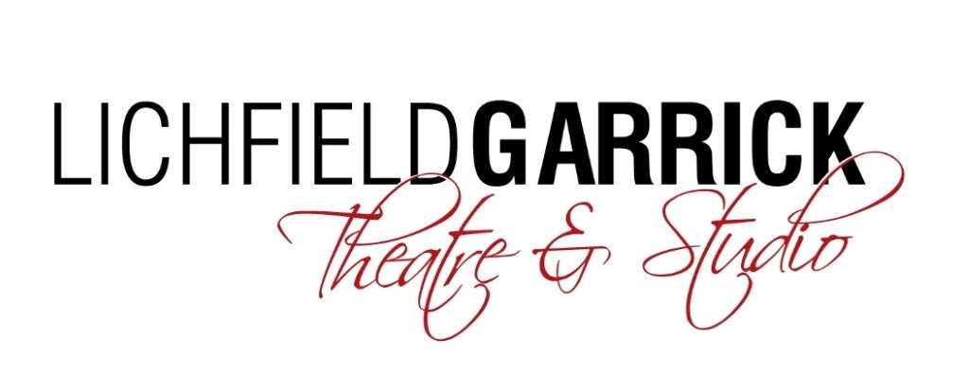

Head of Lighting and Deputy Technical Manager

Thank you for your interest in the Head of Lighting and Deputy Technical Manager post at the Lichfield Garrick.

Please find a job description and some background information enclosed.

How to Apply:
Please complete and return the application form and equal opportunities form from the website and return this to recruitment@lichfieldgarrick.com:-

Deadline for applications is 5pm on 25th March 2019.
Interviews will be during the week commencing 1st April 2019.

We look forward to receiving your application and thank you for your interest in Lichfield Garrick.

Background information

Lichfield Garrick is a producing house, a receiving house, a cultural hub at the heart of the city and district of Lichfield and has a thriving community and outreach programme. As a modern, purpose-built theatre in Lichfield, the Garrick has an enviable programme of performances including drama, musicals, comedy, concerts, film and local theatre. We have built up a huge following for our amazing pantos with Dick Whittington last year, bringing well over 30,000 people through our doors. Our summer time community musical attracts performers and audience from a wide range of people and this year our youth theatre will be performing as part of the NT Connections project.

The main auditorium seats around 550 people, with no restricted viewing and allocated wheelchair spaces. The Studio is more flexible, offering an intimate space that can be arranged in a number of different layouts and seating up to 150 guests.

With a commitment to supporting the local community and the people within it, the Lichfield Garrick runs several programmes designed to offer opportunities, networking and placements in a professional environment. These include the Lichfield Garrick Young Rep and Community Choir, the Morning Chorus daytime choir and outreach work with schools and groups around the district. We also have business relationships and hire our premises for outside activities.

Our programme is strong on traditional drama, but we are also building a new work strand and aim to support local and emerging artists. We are building our family audience and have a strong music following. The variety of other performances also offers opportunities for patrons with a wide range of tastes to enjoy a quality night out in the heart of the beautiful city of Lichfield. We are delighted that the theatre is now attracting help and advice from the Arts Council England and we aim to turn this into support by way of grants in the future.

We have a grant from our Local District Council, but in the current public funding situation, this is being reduced and we aim to introduce more commercial income streams to close this gap. This role will be supporting senior managers in bringing artists to the theatre as both received shows and as part of our own in-house productions. This role will also take the lead in developing our cinematic offering and building a new audience for this line of programming.

JOB DESCRIPTION

Post Title: Head of Lighting and Deputy Technical Manager

Salary Grade: commensurate with experience.

Responsible to: Technical and Production Manager

Responsible for: Lichfield Garrick full time technical staff and casual technicians as delegated by Technical and Production Manager

Main Purpose of Post:

- To assist the Technical and Production Manager with the overall successful management of the facility through the safe and efficient provision of technical and associated services.

- To assist in the creation and production of the highest artistic and technical work standards by facilitating the work of the technical department.

- To aid in the technical operation of the Lichfield Garrick including provide lighting, where appropriate, and technical support of all productions, conferences, meetings and rehearsals at the Lichfield Garrick.

- To deputise for the Technical and Production Manager as appropriate.

- To act as a duty technician during shows including supervising the operation of technical areas at the Lichfield Garrick, at all times during amateur performances, professional shows and events ensuring a high level of Health & Safety compliance.

Main Duties

- Assume day to day responsibility and management of all technicians and ensure the building is run to a very high standard at all times.

- Take responsibility for all lighting equipment, including stock taking, maintenance, repairs and replacement of items. In conjunction with the Technical Manager ensure that there is adequate equipment and consumables on site fit for show use.
- Monitoring and maintenance of the Theatre’s equipment. Produce a schedule for PAT testing of electrical equipment and assist in the implementation of this task.

- To ensure that all stage and storage areas are kept in a safe, tidy manner, complying with relevant Health and Safety legislation.

- To check stock levels in advance and forward appropriate orders, ensuring that the department always has sufficient amounts of consumables.

- Liaise with all amateur hirers prior to their hire date to ensure all technical information has been received and recorded.

- To operate technical equipment effectively and safely after appropriate training.
- To liaise with visiting performers, hirers and technicians to ensure the smooth running of events.

- To assist in the recruitment, induction and mentoring of casual staff and apprentices when required.

- To build up relationships with colleges and universities in order to recruit placement students for Lichfield Garrick Theatre productions.

- To represent the Technical Manager at Policies and Procedure meetings when required.

- To assist in the training of Lichfield Garrick staff and amateur company members.

- To assist in pre- production activities as and when required by the Production Manager. Duties to include CAD drawings for in house Productions.

- Ensure the building is open in the morning and secured safely at night in conjunction with the Front of House Manager and Duty Managers, ensuring that all areas of the building are clean and safe and maintained to a high standard, protecting the health and safety of the public, contractors, users, hirers, staff and visitors.
- In partnership with the Technical Manager, to implement the Lichfield Garrick’s Health and Safety policies including risk assessments and regular reporting.

- To undertake First Aid training and assume responsibilities for First Aid delivery as required.

- Contribute to the good housekeeping of the department

- Maintain good and effective working relationships with all customers, users, colleagues and managers.

- Maintain good standards of work, contributing to the department’s safe, efficient, economic and high-quality performance.

- Adhere to the venue’s Health and Safety Policy and relevant current legislation.

- Undertake any duties that the management may reasonably require.

- Keep up to date with developments in theatre technology.

- Maintain an accident book.

- Act as key holder for the venue.

- To organise receipt and storage of all delivered goods for the operations and events at the Lichfield Garrick.

- Maintain show reports and health and safety checks for all productions.

The Lichfield Garrick reserves the right to vary the content of the job description, after consultation, to reflect the changes to the job without changing the general character of the post or level of responsibility.

General

- The Lichfield Garrick is committed to the development of new theatre practitioners and audiences, especially when involving young people. Although much of the work is fundamental to such development and is the responsibility of Community and Education Manager, heads of departments and all staff are expected to contribute in appropriate ways.

- It is the responsibility of every member of staff to assist in presenting the Lichfield Garrick to the public as a positive, efficient and welcoming organisation.

Person Specification

Essential Criteria | Desirable Criteria | Means of Selection
Experience  Excellent knowledge of Theatre  Equipment and safe working practice  At least 1 year’s experience as an electrician in a performing arts venue.  Experience of working to designer’s specifications. |  | Application Form / Interview
Qualifications / Training  Education to at least GCSE level or equivalent  Advanced level Technical Qualification applicable to theatre.  Prepared to undertake First Aid Training to become one of Lichfield Garrick’s official First Aiders  Knowledge  Knowledge of the range of  technical equipment required  In a theatre.  Knowledge of current Health and Safety legislation | Technical/electrical  qualifications applicable  to post  Knowledge of touring theatre and musical entertainment.  Knowledge of Union agreement (BECTU) and Working Time Directive. | Application form /  qualifications  Interview
Skills and Abilities  Focused approach in dealing  With technical enquiries  Ability to work well under pressure, to be self reliant and self motivated.  Ability to think creatively.  Ability to work as part of a team | Ability to read and interpret technical drawings.  Ability to work with numbers | Application form  Application Form / interview  Interview
Special Attributes  A meticulous attitude to deadlines.  Able to work flexible and outside normal office hours including evenings, weekends and bank holidays.  Capable of dealing with demanding physical activities.  A genuine interest in theatre. | A full clean driving license. | Interview  Interview

TERMS OF EMPLOYMENT

Salary: £21,500 - £23,500 pa, depending on experience.

Hours: 40 per week (Full-time)

Period of contract: Permanent, including a six-month probationary period.

Reports to: Technical and Production manager.

Notice Period: 2 months following a six month probationary period.

