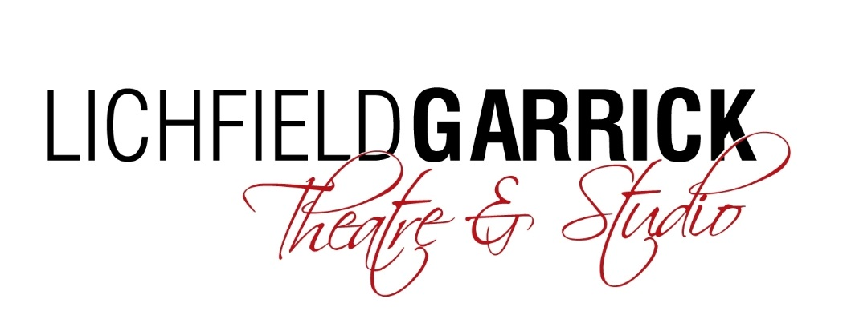

JOB DESCRIPTION

Post Title: Casual Front of House Manager

Salary Grade: £11.10 (inc Holiday pay)

Responsible to: Front of House & Events Manager

Hours: Casual hours to include evenings, bank holidays and weekends

WHO WE ARE
Lichfield Garrick is a producing house, a receiving house, a cultural hub at the heart of the city and district of Lichfield and has a thriving community and outreach programme. As a modern, purpose-built theatre in the Garrick has an enviable programme of performances including drama, musicals, comedy, jazz, film and local theatre. This year we have an amazing production of Cinderella, amongst other things planned for the pantomime season.

KEY RESPONSIBILITIES

People

- To undertake the Duty Manager role on the Lichfield Garrick site on a casual basis, which includes, but is not limited to: the management the Front of House operation in partnership with the Front of House Manager through the compilation and maintenance of running shows (operating as a “Show Duty Manager” or “Show DM”, as they are colloquially known)
- To ensure all new & existing staff have correct uniform and building access equipment during a performance and/or customer facing
- Manage the Lichfield Garrick’s volunteers during a duty Manager shift
- Any other duties requested by the Front of House Manager or Senior Management Team appropriate to the role.

Shows
- To undertake the Duty Manager role on the Lichfield Garrick site on a casual basis, which includes, but is not limited to: the management the Front of House operation in partnership with the Front of House Manager through the compilation and maintenance of running shows (operating as a “Show Duty Manager” or “Show DM”, as they are colloquially known)
- To manage events, taking responsibility for all operational implementation and post activities when Duty Manager. To liaise with both the Box Office and Development Managers to ensure that hires and sponsorship requirements receive a smooth, efficient and professional service from the Lichfield Garrick staff
- To ensure qualified First Aid provision is available at all public performances / events. To replenish first aid provision on a regular basis
- To order ice cream stock, and any other FOH related items
- To maintain & archive the accident, show report, stock, risk assessment folders including replenishing when necessary

Building

- To be a key holder
- In partnership with the Technical Manager/Technical Team or designated duty technician ensure the building is open for performance and secured safely at night
- To ensure all new & existing staff have correct uniform and building access equipment during a performance and/or customer facing
- In partnership with the Front of House Manager and the Technical Manager, to implement the Lichfield Garrick’s Health & Safety policies including risk assessments and regular reporting

The Lichfield Garrick reserves the right to vary the content of the job description, after consultation, to reflect the changes to the job without changing the general character of the post or level of responsibility.

How to Apply:
Please complete an application form and equal opportunities form (download from our website) and send it to:

Helen Cunningham
Front of House & Events Manager
Lichfield Garrick Theatre
Castle Dyke
Lichfield
WS13 6HR

recruitment@lichfieldgarrick.com

Deadline for applications is midday on 28th August 2019.

We look forward to receiving your application and thank you for your interest in Lichfield Garrick

