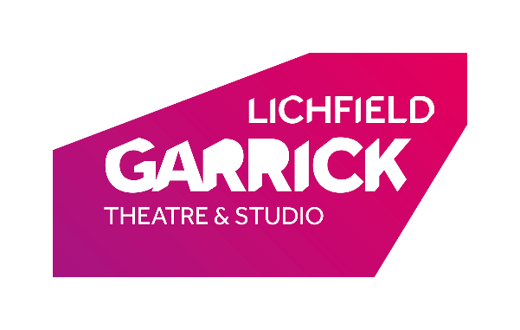
Call out for Writers:

Working Title: The Mincepie Mouse

Short play for two actors aimed at children aged 2 – 7 years.
The Lichfield Garrick Theatre is commissioning a charming script for our 2020 children’s studio production for Christmas 2020.
Fee: £2500
Production Timescale:
Image and blurb deadline: 1st April 2020
First draft of script – Late to mid April 2020
Final script deadline – 1st August 2020
Casting – June 2020
R+D – during week commencing 14th September 2020
Rehearsals begin Monday 16th November 2020

The Lichfield Garrick
The Lichfield Garrick is a modern purposed built theatre first opened in 2003. It plays host to the best and widest range of musical theatre, drama, comedy, music and family entertainment in the City of Lichfield. In 2013 the Lichfield Garrick moved to charitable trust status. The theatre has recently won the UK Theatre Award for the West Midlands Most Welcoming Theatre and The What’s On Award for Staffordshire’s Best Arts Venue/Theatre.
The Lichfield Garrick is home to over 400 performances each year in its two theatre spaces with the theatre, capacity 540, and the studio, capacity 150, together with a newly started cinema offering.
The Lichfield Garrick regularly produces and co-produces work, runs an Artist Development and a Community Engagement programme. The Garrick also runs weekly programmes including The Morning Chorus and The Garrick Young Rep Acting Companies and a community musical.

Context: in 2018 we produced our first in-house production of a Christmas show for children (Elf and Reindeer’s Christmas Cracker), this was followed by another successful show in 2019 (Charlie and the Christmas Cat). In addition, we produce an adult farce which plays in the studio in the evenings whilst the children’s show runs in the mornings.
The studio is an end on, 150 seat black box auditorium with a basic, but effective lighting rig and full cinematic surround sound.
Requirements:
Run time: a full production lasting approximately 40 minutes with no interval.
Creative team: Director: tbc, in-house lighting and sound design
Cast: 2 actors
Content: with the working title The Mince pie Mouse/Mice, the aim is for the play to have two characters, one of whom (or both of whom) is a mouse. We are looking for a play which leads the characters on a learning arc such as ‘try, try again’ and which gives its young audience a taste of theatre making which is both a magical experience and educational.
An example of how this might be interpreted is that the mouse (or mice) start the play sitting inside a mince pie and think that they could make one of their own. They then experiment finding the right ingredients and finally successfully make some mince pies which they decide to leave out for Santa. The final part of the play is them going to sleep, there’s a quick Ho, Ho, Ho and the pies magically disappear perhaps replaced by a gift from Santa as a reward for try, try, trying again.
The above is for illustration only and you are encouraged to be creative in sending your characters on a developmental/learning journey. We like to encourage interaction with the audience.

Age group: 2 – 6 years
Application: Please send a CV, a previously written scene for children of an appropriate age and one side of A4 outlining your idea (synopsis of plot including the arc the characters will follow, character list and a general idea of the kind of setting in which you are basing the story).
Applications should be sent to amy.pears@lichfieldgarrick.com by 9am on 2nd March 2020. If you have not heard back by the end of March, please assume that you have not been successful.

