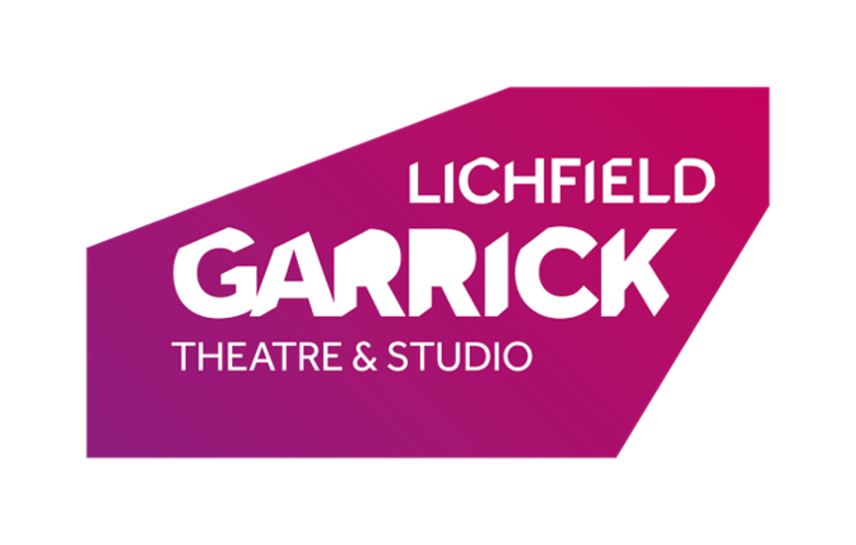
Page to Stage: Producing Theatre Application Form.

Thank you for your interest in joining the Page-to-Stage: Producing Theatre course. Once completed, please e-mail your application form to education@lichfieldgarrick.com. Please note that taking part in the course costs £85 for the full course and resources. If paying this fee is a challenge, then please see our Funded Places Section.

Please Read/fill in all sides of the form and the declaration.

Name:
Address:
Email Address (Of Parent/Guardian if Under 18):
Home Telephone:
Mobile (If under 18 please ignore and fill out the below):
If under 18
Parent/Guardian/Carer Name:
If under 18
Parent/Guardian/Carer Mobile:
Age:
Date of Birth:
Preferred Gender Pronouns (e.g her/she, he/him, they/them):
Do you have any access requirements?

Key Information
Sessions will run from 18:30-21:00 Each Tuesday from November 3rd 2020 with a final session on Friday 18th December 2020.
All sessions will be run virtually through a video conferencing application.

You must be over 16 years of age to take part in this course. Applications from any outside of this age bracket will be refused.

Key Requirements
As the delivery of the course is delivered virtually, it is your responsibility to ensure your availability and that you will have internet access capable of maintaining your virtual presence (e.g a Zoom call) for the full duration of the session.

Tell us a little bit about your prior experience producing theatre (this is not required for the course, it is to help us pitch the material of the course effectively).

Funded Places
We at the Lichfield Garrick believe that everyone is deserving of the chance to engage with creative activities, and this is why we endeavour to provide Funded Places to those whom face financial barriers to attendance. A funded place waives the registration fee for a participant. Funded places are offered on a case-by-case basis, there are no specific requirements that must be met in order to qualify. Asking for a funded place will not affect consideration of your application.
Would you like to be contacted with more information about a Funded Place (Please highlight the applicable) YES/NO?

PLEASE PROVIDE CONSENT FOR THE FOLLOWING. IF THE PARTICIPANT IS UNDER 18, PLEASE PROVIDE PARENT/GUARDIAN CONSENT FOR THE FOLLOWING (Please tick all that apply):
1. Future contact about similar learning projects by email
2. Use of image in photographs for promotion of this project or future Lichfield Garrick projects, with name accompanying image
3. Use of image in photographs for promotion of this project or future Lichfield Garrick projects, without name accompanying image
6. Permission for self/child to be recorded when accessing digitally delivered sessions as part of safeguarding policy. (These recordings will be securely stored,
and only accessed if necessary for safeguarding practices).
If you would like more details on any of the above statements before consenting, then please get in touch as soon as possible using the details at the top of this form.

Your data will be kept for the duration of the rehearsal and performance process after which it will be securely disposed of. If you have given consent to option 1 of the above statements, then we will keep your data until two years after we cease to have any further interaction with you. If you have given consent for options 2-3 then we will keep your data indefinitely. You can withdraw consent or ask us to delete your data at any time.
PARENT/GUARDIAN SIGNATURE
. . . . . . . . . . . . . . . . . . . . . . . . . . . . . . . . . . . . . . . . . . . . . . . . . . . . . . . . .

