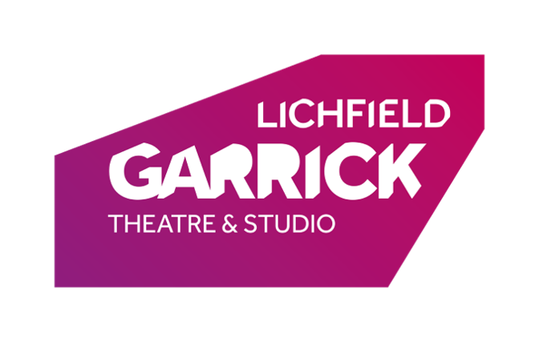
Attending a Zoom Meeting/Session

How Do I Attend a Virtual Meeting/Session?
To attend a virtual meeting/session at the Lichfield Garrick Theatre, you will need Zoom, this is the platform that the Theatre is currently using to host its meetings/sessions, should this change, we will update you as soon as possible!
Your Host Facilitator will email out a link to a scheduled meeting, and all you need to do, is have your computer ready, click the link and it will take you to the meeting room where the facilitator can let you in! This link will only have been given to members of the relevant group, so you should not have to navigate any other areas to access the meeting.
*Please make sure to always check the email address that you have received the invitation from before clicking any links to ensure that it is a legitimate invitation*

How Do I Need to Prepare for a Virtual Meeting/Session?
This depends first on whether this meeting/session will use video feed or not. However, before any meeting/session you should always:
- Make sure that you are seated comfortably and have space around you if your session will require any movement.
- It is a good idea to have some water within reach of your computer so that you can stay hydrated during the session, (equally if you wish to bring a hot drink to the meeting feel free to do so!)
- Ensure that you are connecting to the meeting/session through your home internet, which is a password-secure connection, please do not connect to a session through an open connection.
- Check for any residual noise in the background, if there is anything that would be especially distracting or inappropriate, remove the source of the noise where possible.
  - If the noise is distracting and not able to be removed, then consider muting your microphone apart from when you are speaking and using headphones to help you focus on the meeting/session.
  - If the noise is inappropriate (songs with inappropriate lyrics) or age-inappropriate discussions happening in the background, then you will need to either remove the source of the noise or move yourself away from it.

Sessions with video feed will also require you to:
- Check the background of your webcam feed, to ensure that there is nothing inappropriate for the session in the image.
- Ensure that no-one except you is contained within the image (your guardian is free to appear in the image, but does not need to sit within view for the session).

How Am I Kept Safe During a virtual meeting/session?
There are a number of rules for both participants and facilitators to follow, which are intended to keep everyone safe.
- Every meeting/session is recorded for safeguarding purposes.
  - This recording will be taken by the Host Facilitator and will be securely stored upon the Lichfield Garrick’s network, and will only be accessible to the Safeguarding Team. Recordings will not be accessed by any other members of staff for any purpose and will only be shared with external facilities in the event of providing evidence in a Safeguarding Investigation.
- Only the Host Facilitator is permitted to record any part of the session.
  - If you spot that another facilitator or participant is recording a part of the session, please inform the Host Facilitator immediately. Any recordings taken without permission will result in immediate dismissal of either participant or facilitator.
- All meetings will be securely passworded so that only invited participants may enter.
  - Should someone enter the meeting who does not appear to have been invited, please inform the Host Facilitator immediately.
- It is the responsibility of anyone sharing video feed, that the video image does not contain personal details/inappropriate imagery.
- Video Feeds should not include the image of anyone who is not the participant or the guardian, should other members of the participants home circle enter the image, it is requested that the participant turn off their video until the image is clear once more.
  - We certainly appreciate that everyone has walkthroughs in their home or siblings that can appear suddenly, so please do not be afraid of being told off for this occurring, but due to the fact that we are recording the session, we are keen that we capture as little as possible of anyone whom has not consented to being recorded as possible.
- Please do not attempt to take personal details from a Zoom meeting/session through attempting to view someone’s account or otherwise.
  - We appreciate meetings/sessions contain a social aspect, but similar to physical sessions, you must ask permission and for any contact details should you wish to contact another member of the group. You are not entitled in any way to this information should the member refuse.
- In the event of a participant being under the age of 18, please use a parent/guardian’s Zoom account.
- All facilitators/responsible adults will be subject to DBS checks and monitored in precisely the same way as when operating physical sessions.

How do I report a Safeguarding Concern?
If you feel that these rules are not being followed, or a facilitator/participant is behaving inappropriately there are several ways you can make us aware of this.
In an immediate setting:
- You can verbally inform the Host Facilitator that you are uncomfortable.
- You can privately message the Host Facilitator to inform them of the inappropriate behavior using the chat function. (please be aware that all chat messages sent will be recorded for safeguarding purposes).
At the end of the meeting/session: You are always free to ask to talk to the Host Facilitator at the end of the session prior to disconnecting.
Following the meeting/session: You can email our Designated Safeguarding Officer Liz Porrett at liz.porrett@lichfieldgarrick.com or our Deputy Safeguarding Officer Jonny McClean at jonny.mcclean@lichfieldgarrick.com. Should you want to speak directly to either member of staff, you can call 01543 412 128 for Jonny McClean, or 01543 412 114 for Liz Porrett.

How Do I Need to Behave During a Virtual Meeting/Session?
You don’t need to behave any differently to how you would when attending a physical session, regardless of setting, our code of conduct remains the same. Please see the below:
By participating as a member of this group, I agree to the following:
- I will treat all group members/facilitators with respect and kindness.
- I will help support a fun, friendly environment.
- I will encourage a supportive and creative environment, where it is acceptable to try ideas, and get things wrong!
- I will follow all the safety procedures for the building and will follow any instructions related to Health and Safety immediately when given.
- I will take every care to ensure that my mental, and physical health is not compromised by being a part of this group.
- I will do my best to be punctual to meetings/sessions.
- I will not humiliate or belittle any members of the group/facilitation team.
- I will not contact any members of the group/facilitation team outside of the theatre environment without first seeking their permission.
- I will not take photos of participants/facilitators during meetings/sessions and post on any social media without express permission of all parties in the photo.
By operating as a theatre, we agree to the following:
- We will treat every member of the group/facilitation team with respect and kindness.
- We will be a constructive and supportive presence in the room.
- We will encourage mistakes and support creative efforts.
- We will ensure that you are always aware of safety procedures.
- We will ensure that you have clear avenues for support regarding Safeguarding, Mental Health and Physical Health.
- We will approach bullying or intimidating behavior with zero tolerance.
- We will take all Safeguarding concerns seriously, and these will be investigated.
- We will not humiliate or belittle any members of the group/facilitation team.
- We will only take photos of participants/facilitators and post on social media with express official permission of all parties in the photo.

What should I do if I am Unwell?
- Please email us if you are not well enough to attend a session.
- Although physical attendance may be possible due to the virtual nature of the meeting/session, we recommend that should you feel unwell, that you focus on recovery, and do not force yourself to attend the session.
- If you need to leave the meeting at any time due to feeling unwell, either physically/mentally, then please just let us know that you are leaving, and then leave the meeting as/when you feel is necessary.
- We at the Lichfield Garrick Theatre take mental health as seriously as we do physical, so should you need to miss a session, or remove yourself from a session in aid of mental/emotional wellbeing, please just let us know you will be missing the session/removing yourself from the session early and do so as/when you feel is necessary. If you need any extra support during sessions, please inform either the Designated Safeguarding Officer, or one of the members of staff leading the session, and we will do our best to ensure that the appropriate provisions are in place for you.

