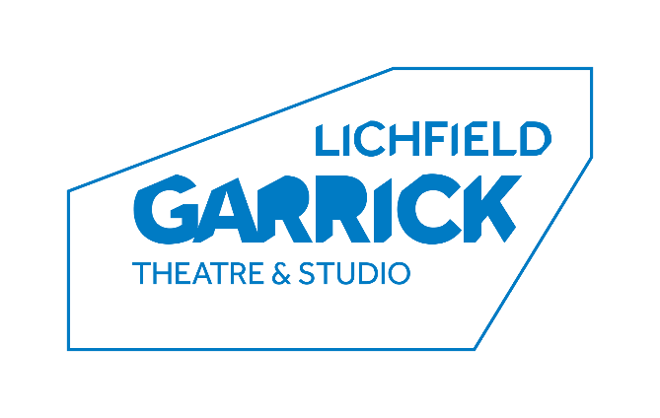
Front of House Manager

Thank you for your interest in the Front of House Manager post at the Lichfield Garrick.
The successful candidate will have the drive to deliver great customer service, increase additional spend throughout the theatre and to have the imagination and creativity to initiate projects, organise events and inspire their team. Do not apply unless you are prepared to work hard, enjoy a challenge and smile through long, busy and noisy days. If you can deliver an amazing, unforgettable and exciting programme of shows to 130k or more people every year, then keep reading!

Please find a job description and some background information enclosed.

How to Apply:
Please complete an application form and equal opportunities form (available for download from our website - www.lichfieldgarrick.com) and send it to:

Karen Foster, Chief Executive, Lichfield Garrick
Castle Dyke, Lichfield WS13 6HR

Or by email to: recruitment@lichfieldgarrick.com

Closing date: 12th July 2021
Interviews: week commencing 19th July 2021

We look forward to receiving your application and thank you for your interest in Lichfield Garrick.

Karen Foster

Background information

Lichfield Garrick is a producing house, a receiving house, a cultural hub at the heart of the city and district of Lichfield and has a thriving community and outreach programme. As a modern, purpose-built theatre in Lichfield, the Garrick has an enviable programme of performances including drama, musicals, comedy, concerts, film and local theatre. We have built up a huge following for our amazing pantos bringing well over 30,000 people through our doors. Our summertime community musical attracts performers and audience from a wide range of people and this year we are embarking on the task of writing our own community musical.

The main auditorium seats around 550 people, with no restricted viewing and allocated wheelchair spaces. The Studio is more flexible, offering an intimate space with raked seating for up to 150 guests.

With a commitment to supporting the local community and the people within it, the Lichfield Garrick runs a number of programmes designed to offer opportunities, networking and placements in a professional environment. These include the Lichfield Garrick Young Rep, Community Choir, and outreach work with schools and groups around the district. We also have business relationships and hire our premises for outside activities.

We are proud to be opening currently, supporting opportunities for performers and technicians to return to working in the theatre. Our programme is strong on traditional drama, but we are also building a new work strand, building our family audience and have a strong music following. The variety of other performances also offers opportunities for patrons with a wide range of tastes to enjoy a quality night out in the heart of the beautiful city of Lichfield. We are delighted that the Arts Council England has supported us throughout the pandemic leaving us in a position to re-build with an experienced team who have stayed together throughout the year.

We have a grant from our Local District Council, but in the current public funding situation, this is being reduced and we aim to introduce more commercial income streams to close this gap. This role will lead on increasing business and yield from food and beverage, building additional spend across the building and working with the Chief Executive to deliver new and potentially external income streams to help support the core business of providing the best entertainment and community activities possible.

JOB DESCRIPTION

Post: Front of House Manager

Reporting to: Karen Foster (Chief Executive)

Responsible for: Green Room staff, Deputy Front of House Manager and FoH team

Overview of the post:

1. To strategically manage the FOH team, FOH facilities and FOH activities.

2. To manage the Front of House department ensuring that budgets and income targets are monitored and achieved or exceeded through good business practices, to ensure that sufficient personnel are recruited, trained and available to staff activities and to create and manage an incentive scheme for the department.

3. To take responsibility for and to increase all income generating activities within the building, and with particular emphasis on night-time sales in bars, additional spend on merchandise and working with the Chief Executive to implement new activities in the Green Room café area.
4. To manage department budgets, ensuring that Green Room activities are fully costed, gross profit budgeted and monitored, additional spend is monitored and increased, that budgets are set, monitored and adhered to in order to maximise profit. Ensure that all income streams match or exceed budget.
5. To ensure that the customer receives a warm welcome, great customer service and an efficient team leading to a pleasurable and safe visit. Whilst Covid measures are in place to ensure that these are embedded in FOH procedures and to ensure staff follow government guidelines.
Main Duties
Front of House:
- To oversee the Front of House department. In conjunction with the Deputy Front of House Manager, organise training & recruitment to ensure that professional standards of behaviour are set and maintained. Oversee the induction of new staff. Rota Duty managers as and when appropriate.
- To undertake some shifts as Front of House Manager.
- Identify and implement additional spend strategy, taking responsibility for ensuring that the Front of House team are trained in sales techniques, are incentivised to deliver results and that all members of the FoH team have a consistent approach.
- To develop and implement an incentive scheme for the department.
- To ensure that there are sufficient trained staff to run the venue at all times and within licensing legislation. To ensure that personal licence is in place and that the staff lists are up to date.
- To oversee all public activities taking place in Front of House areas, being responsible for health and safety, covid security and customer welfare. This will include hire events, ancillary activities during the year and shows in both studio and mainhouse.
- Be responsible for standards of dress and behaviour of FOH team, including ordering and distributing uniform and name badges.

Green Room Café and Bars:
- To manage the Green Room bars to ensure that profit is maximised.
- Post covid, we have an opportunity to approach the Green Room activities with innovation and imagination. The postholder will be expected to work with other senior managers to develop and then deliver change. The postholder must aspire to be entrepreneurial in their development of our spaces.
- To set budgets in association with Chief Executive, to monitor activities and spend throughout the year and to report to Chief Executive how sales and budgets are progressing.
- To ensure that Green Room and bars activities are fully costed, gross profit levels maintained and that staffing is adequate for the level of customer activities. To lead on developments to the Green Room and bars in consultation with senior staff, ensuring that business cases are prepared and followed. To lead on negotiations with contractors, ensuring best value on all arrangements.
- To oversee procedures for ordering stock, overs and unders, stock write off etc, in order to ensure the most efficient use of resources
- To undertake, in conjunction with other departments, publicising Green Room activities and organising income generating activities. This should include seasonal and show related themes, allowing for innovative marketing within venue brand guidelines through publicity, social media, events and offers.
- Monitor and enforce cleanliness, best practice and health and safety standards at all times and in all food and beverage spaces.
- Manage and sell hire events

General:
- To be a daytime duty manager, taking responsibility for the building and its security.
- To lead the Health and Safety Committee in conjunction with our H&S advisor.
- To be a key holder.
- Excellent communication with all staff and line manager.
- To liaise with third party and internal staff over work experience, apprentice and trainee staff.
- Oversee and ensure the implementation of all Lichfield Garrick Health & Safety policies including risk assessments and regular reporting for the whole of the front of house areas and activities.
- To maintain a high-quality physical environment throughout all Front of House areas within the Lichfield Garrick and take responsibility for planning the maintenance and/or replacement of equipment
- Any other duties as requested by the Chief Executive, appropriate to the role.

The Lichfield Garrick reserves the right to vary the content of the job description, after consultation, to reflect the changes to the job without changing the general character of the post or level of responsibility.

PERSON SPECIFICATION

Essential

- Exceptional communication skills, both written and spoken
- Absolute attention to detail
- Ability to prioritise and work to strict deadlines
- Ability to manage change
- Goal oriented
- A high standard of organisation and efficiency
- Confident networking with a range of clients
- Good team-working skills
- Ability to engage and motivate people from all different backgrounds
- Ability to self-start
- A genuine enthusiasm for theatre
- Computer literacy including a knowledge of till software and programming
- A good range of useful contacts
- Creative mindset – with the aim of building up the bars and café

A creative and innovative person, they will be happy to introduce new ideas, research new products and procedures and to implement a programme of events which will be beneficial to the theatre. They will be confident dealing with the public and their staff team.

Desirable

- Experience of managing a café, bar or restaurant, preferably in a theatre environment
- Experience of running Front of House teams in a theatre environment
- Experience of managing people, motivating staff and developing a sales culture
- Experience of managing food and beverage preparation and service
- Experience of training a team in upselling and cross selling
- A basic understanding of financial budgets and annual accounting.
- Personal licence holder
- Knowledge of health and hygiene legislation and the ability to implement relevant policies
- An up-to-date understanding of current issues and trends in catering

TERMS OF EMPLOYMENT

Salary: £25,000 - £30,000
Period of contract: Permanent, including a six-month probationary period

Hours: 40 hours per week – flexible to suit work patterns
Evening and weekend work will be required, an informal Time Off In Lieu system operates.
Holiday: 28 days per annum, 8 of which are Bank Holidays

Notice Period: 2 months

