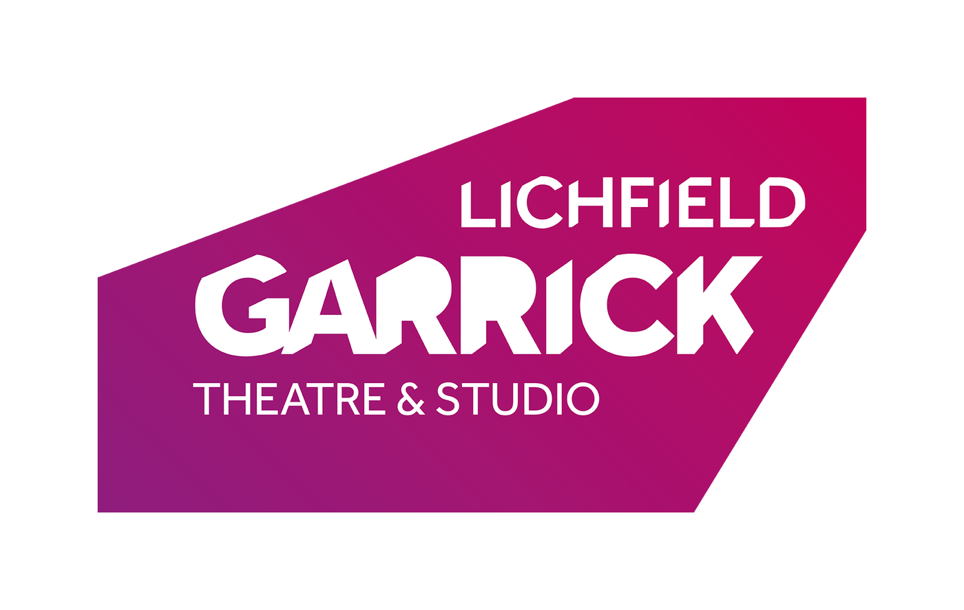
Casual Front of House Manager

Thank you for your interest in the Casual Front of House Manager post at the Lichfield Garrick.

Please find a job description and some background information enclosed.

How to Apply:
Please complete an application form and equal opportunities form (download from our website) and send it to:

Lichfield Garrick
Castle Dyke,
Lichfield WS13 6HR

Or email: recruitment@lichfieldgarrick.com

Deadline for applications is midday on 4th October 2021
We look forward to receiving your application and thank you for your interest in Lichfield Garrick.
Background information

Lichfield Garrick is a producing house, a receiving house, a cultural hub at the heart of the city and district of Lichfield and has a thriving community and outreach programme. As a modern, purpose built theatre in Lichfield, the Garrick has an enviable programme of performances including drama, musicals, comedy, jazz, film and local theatre. This year we have an amazing production of The All New Adventures of Peter Pan, amongst other things planned for the pantomime season.

The main auditorium seats 551 people, with no restricted viewing and allocated wheelchair spaces. The Studio is more flexible, offering an intimate space that can be arranged in a number of different layouts and seating up to 150 guests.

With a commitment to supporting the local community and the people within it, the Lichfield Garrick runs a number of programs designed to offer opportunities, networking and placements in a professional environment.

With the recent appointment of a new executive team, we are building up our family audience, with successful monthly family events and shows. We are delighted that the theatre is now attracting help and advice from the Arts Council England and we aim to turn this into support by way of grants in the future. Our programme is attracting new and returning audiences into the theatre, whilst our Green Room café is building on its current clientele to welcome more and more people into the theatre during the day.

A recently built community stage is also supporting local artists and we are welcoming visual artists to the theatre by offering gallery space.

The Front of House team includes show managers, operations assistants and Green Room café and bar staff. This team is responsible for the welcoming and guiding of our patrons, for selling merchandise and food and for ensuring that queries or problems are dealt with swiftly and efficiently.

JOB DESCRIPTION

Post Title: Casual Front of House Manager

Salary Grade: £11.10 per hour (inc Holiday pay)
Responsible to: Front of House Manager

Hours: Casual hours to include evenings, bank holidays and weekends

KEY RESPONSIBILITIES

People

- To undertake the Duty Manager role on the Lichfield Garrick site on a casual basis, which includes, but is not limited to: the management the Front of House operation in partnership with the Front of House Manager through the compilation and maintenance of running shows (operating as a “Show Duty Manager” or “Show DM”, as they are colloquially known)
- To ensure all new & existing staff have correct uniform and building access equipment during a performance and/or customer facing
- Manage the Lichfield Garrick’s volunteers during a duty Manager shift
- Any other duties requested by the Front of House Manager or Senior Management Team appropriate to the role.

Shows
- To undertake the Duty Manager role on the Lichfield Garrick site on a casual basis, which includes, but is not limited to: the management the Front of House operation in partnership with the Front of House Manager through the compilation and maintenance of running shows (operating as a “Show Duty Manager” or “Show DM”, as they are colloquially known)
- To manage events, taking responsibility for all operational implementation and post activities when Duty Manager. To liaise with both the Box Office and Development Managers to ensure that hires and sponsorship requirements receive a smooth, efficient and professional service from the Lichfield Garrick staff
- To ensure qualified First Aid provision is available at all public performances / events. To replenish first aid provision on a regular basis
- To order ice cream stock, and any other FOH related items
- To maintain & archive the accident, show report, stock, risk assessment folders including replenishing when necessary

Building

- To be a key holder
- In partnership with the Technical Manager/Technical Team or designated duty technician ensure the building is open for performance and secured safely at night
- To ensure all new & existing staff have correct uniform and building access equipment during a performance and/or customer facing
- In partnership with the Front of House Manager and the Technical Manager, to implement the Lichfield Garrick’s Health & Safety policies including risk assessments and regular reporting

The Lichfield Garrick reserves the right to vary the content of the job description, after consultation, to reflect the changes to the job without changing the general character of the post or level of responsibility.

Person Specification

Essential Criteria | Desirable Criteria | Means of Selection
Experience  Experience of managing a multi-skilled team in a performance environment.  Experience of managing a team of volunteers.  Experience of working in a customer focused environment.  Excellent communication skills.  Cash handling and reconciliation skills. | First Aid at work / Full First Aider.  Good knowledge of general theatre practices | Application Form / Interview  Application Form / Interview  Application Form / Interview  Application Form / Interview  Application Form / Interview
Qualifications  A level or equivalent  Knowledge  Knowledge of the range of FOH duties required in a Theatre.  Operational experience in coordinating a variety of tasks simultaneously.  Knowledge and understanding of current Health & Safety Legislation.  Computer skills  A meticulous attitude to High standards of customer service. | Customer care training  Knowledge of touring theatre and musical entertainment protocols. | Application form /  Interview  Application form /  Interview  Application form /  Interview  Application form /  Interview  Application form /  Interview  Application form /  Interview
Skills and Abilities  Excellent communication and people skills.  A proven ability to handle difficult situations and resolve disputes  Ability to work well under pressure, to lead in an emergency situation, to be self-reliant and self-motivated.  Proven ability to pay close attention to detail.  Ability to work as part of the Lichfield Garrick management team.  Ability to think strategically and plan ahead.  Ability to motivate and manage staff. | Knowledge of banking procedures | Application form/interview  Application Form / interview  Interview  Application form/ Interview  Interview  Application form/ Interview  Application form/ Interview
Special Attributes  Able to work flexible hours to fit with the opening hours of the Theatre, which will include evenings, weekends and Bank Holidays  Commitment to equal opportunities in employment and service delivery. |  | Interview  Application form/  Interview

TERMS OF EMPLOYMENT

Salary: £11.10 per hour

Period of contract: Casual basis

Hours: Casual hours to include evenings, bank holidays and weekends.

Holiday: n/a

