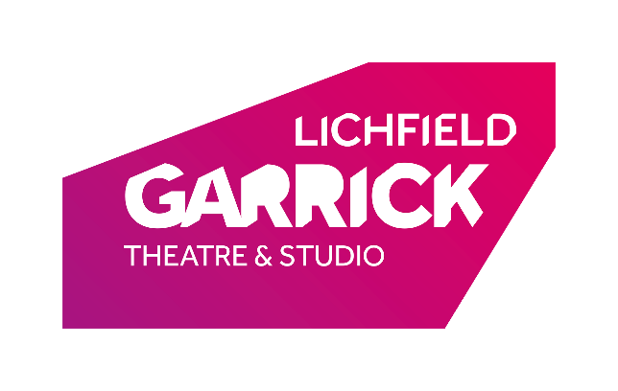
General Manager (Producing)

Thank you for your interest in the General Manager (Producing) post at the Lichfield Garrick.

Please find a job description and some background information enclosed.

How to Apply:
Please complete and return the application form and equal opportunities form from the website and return this to recruitment@lichfieldgarrick.com:-

Deadline for applications is 5pm on 31st January 2022
Interviews will be during the week commencing 7th February 2022

We look forward to receiving your application and thank you for your interest in Lichfield Garrick.

Lichfield Garrick is a producing house, a receiving house, a cultural hub at the heart of the city and district of Lichfield and has a thriving community and outreach programme. As a modern, purpose- built theatre in Lichfield, the Lichfield Garrick has an enviable programme of performances including drama, musicals, comedy, jazz, film and local theatre. We produce highly acclaimed Christmas shows with The All New Adventures of Peter Pan and the Mince Pie Mice having finished their runs over Christmas 2021 and we are currently in the process of working with our community to write and then perform a new musical based on Robin Hood.

The main auditorium seats around 560 people, with no restricted viewing and allocated wheelchair spaces. The Studio is more flexible, offering an intimate space that can be arranged in a number of different layouts and seating up to 150 guests. It also houses Lichfield’s only cinema with full cinematic surround sound and full screen projection.

With a commitment to supporting the local community and the people within it, the Lichfield Garrick runs a number of programmes for young and old to take part in arts activities. Our programme is strong on traditional drama, but we are also building a new work strand and aim to support local and emerging artists. We are building our family audience and have a strong music following. The variety of other performances also offers opportunities for patrons with a wide range of tastes to enjoy a quality night out in the heart of the beautiful city of Lichfield. We are delighted that the theatre is now attracting help and advice from the Arts Council England as well as offering a new escape room, a Santa’s Grotto and a cinema.

The pandemic has been a difficult time for theatres and the wider arts. We have been lucky enough to receive funding from DCMS/Arts Council England and from local sources such as Lichfield District Council, charitable trusts and many individual donations. We have endeavoured to open whenever we have been able to, in order to support the performers and technicians who work on touring shows. Inevitably, the uncertainty of the last 18 months leaves us building up again and this role will be key to supporting the team as we work to bring back audiences, performers and participants in our engagement activities.

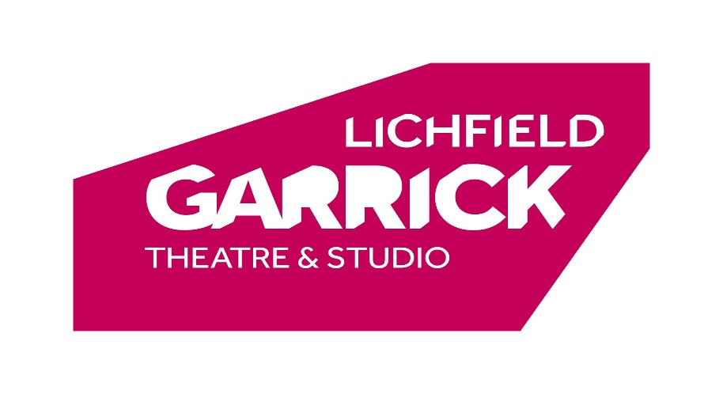
JOB DESCRIPTION

Post Title: General Manager (Producing)

Annual Salary: £30,0000 - £40,000 depending on experience

Hours per week: 40 hours – which includes some Saturdays, evenings &
Bank Holidays.

Reporting to: Chief Executive

Responsible for: Technical Team and Office Manager

Job description

Role

- To support the CEO with productions, projects and general management of the theatre.
- To co-ordinate planning with colleagues working on artistic events, seeking and working with creatives, actors and designer/builders, to ensure that the best possible show is produced in the most financially efficient manner.
- To plan for future life of Lichfield Garrick productions and to ensure that this is a financially viable undertaking.
- To budget all activities (in collaboration with colleagues) and to ensure that every production is kept on target.
- To programme commercial shows (eg tribute acts) into the mainhouse and studio as directed by the programming committee, ensuring that financial targets are met.
- To oversee programme of films in the studio cinema.
- To ensure that all cast and creatives are contracted, having negotiated deals within budget.
- Engage colleagues in marketing, development, community and education, and technical with in-house productions.
- To undertake additional administrative activities as required by the running of the theatre which may not be related to the artistic programme.
- To be a part of the senior management team and to line manage the Technical department.

Responsibilities

Producing:
- To work on all inhouse productions as follows:
- To manage the pipeline of productions, ensuring that each element is delivered in a timely and efficient fashion and in the most environmentally sustainable way possible.
- To be available throughout the busy periods in order to support the productions as required.
- To report to the CEO at every stage of the productions
- Where children or vulnerable adults are involved in a production or received show to consider safeguarding issues and, in conjunction with the Associate Director (Safeguarding lead), ensure that correct procedures are followed.

Pantomime
- Co-production of Panto (currently with Evolution Pantomimes), including seeking and contracting creatives (in collaboration with relevant managers), liaising with co-producers throughout the year
- Negotiating contracts in collaboration with CEO and outside creatives.
- Setting budget and once agreed by CEO, managing delivery within budget.
- Managing relationship with co-producers, cast and creatives and ensuring that project is managed efficiently and delivered to the highest standard.
Christmas studio shows
- Development of production ideas in collaboration with CEO.
- Budgeting productions and, once agreed by CEO, managing the delivery within budget.
- Calling out for writers, creatives and cast and managing the process (in collaboration with CEO and production director)
- Working with production colleagues to ensure sets are planned and built and costumes bought or designed to schedule, creatives are booked and actors cast.
- Negotiate to the best of your abilities and then contract all cast, creatives, writers and physical set providers.
- To work with marketing team to produce images, online content and to enable strategic marketing campaigns which ensure that productions deliver or exceed budgeted income levels
- To input into funding applications where applicable.

Community Shows:
- To work with the Associate Director to develop ideas for the community musical and other young acting company shows, ensuring that the CEO agrees the projects and the planned activities.
- To support the Associate Director in developing a realistic budget for the shows and to monitor its delivery.
- To support the Associate Director in the process of producing the shows including delivery of contracts where necessary and ensuring that schedules are met by all in-house team.
- In conjunction with the Associate Director, ensure that the marketing team are able to produce images, online content and to enable strategic marketing campaigns which ensure that productions deliver or exceed budgeted income levels
- To input into funding applications where applicable.

Programming:

- To receive information from producers and to negotiate deals with commercial producers (ie tribute bands) as directed by the programming committee’s decisions. NB CEO negotiates with dramas and artistic shows for adults and Associate Director programmes children’s shows.
- To lead the film committee and to oversee the cinema programming with blockbusters and live screened productions (cinema programming and scheduling is undertaken by a member of the marketing team).

General:
To deputise for the CEO in her absence.

To deliver own administration to a high standard, ensuring communication within the team and the wider building is exemplary

To lead on sustainability, influencing all departments to consider their environmental impact when making choices of supplier and activity.

To line manage the Technical Team, both for productions and received shows.

To line manage the Office Manager

Manage the training and appraisal records of all staff and manage the training budget

Chair the Policies and Procedures Committee and ensure that all policies are kept up to date. In conjunction with senior managers, ensure that policies and procedures are followed by all staff and that contracts with suppliers (eg) reflect the organisations expectations.

To take on projects or processes outside of the normal scope of other managers, which are likely to vary in time commitment and nature.

To be part of the senior management team and to be a duty manager in rotation with other managers.

To be a key-holder and to ensure that all activities conform to the highest health and safety standards practical.

To deal with complaints about show quality.

Any other duties which may reasonably be requested by the Chief Executive

To maintain a high standard of personal cleanliness and dress appropriate to a Senior Management position within a theatre

This job description may be varied and these roles should not be considered exhaustive.

PERSON SPECIFICATION

Essential Criteria | Desirable Criteria | Means of Selection
Experience  A passion for and understanding of regional theatre and its national context.  Ability to maintain confidentiality.  Strong negotiation skills and the ability to ensure value for money.  Excellent communication skills  Previous experience of producing professional theatre productions.  Computer literate  Awareness of Health and Safety Legislation and good practices.  Ability to prioritise and work to strict deadlines.  Good teamworking skills.  Initiative | IOSH or similar training in Health and Safety  Theatre programming experience. | Application Form / Interview  Application Form / Interview  Application Form / Interview  Application Form / Interview  Application Form / Interview  Application Form / Interview  Application Form / Interview  Application Form / Interview  Interview  Application Form / Interview

Qualifications  Tertiary education | Degree level study, possibly in an arts subject. | Application form /  Interview
Skills and Abilities  Excellent communication and people skills.  Theatre and touring experience.  Knowledge of theatre protocol.  Ability to work well under pressure and remain calm in a busy environment.  Ability to pay close attention to detail.  A high standard of organisation and efficiency.  Ability to work as part of the Lichfield Garrick management team. | Knowledge of technical theatre  Understanding of marketing | Application form/ interview  Application Form / interview  Application Form / interview  Application Form / Interview  Application Form / Interview  Application Form / Interview  Interview
Special Attributes  Able to work flexible hours to fit with the Theatre, which will include evenings, weekends and Bank Holidays. |  | Interview

TERMS OF EMPLOYMENT

Salary: in the range of £30,000 - £40,000 pa, depending on experience

Hours: 40 hours per week. Part-time and/or flexible working may be considered if the right candidate demonstrates how they will prioritise our work and whether they anticipate taking on the whole job description in shorter hours.

Period of contract: Permanent, including a six-month probationary period.

Reports to: Chief Executive.

Notice Period: 3 months following a six-month probationary period.

Holiday: 28 days per annum (including bank holidays). NB holiday during panto is not allowed for all staff.

