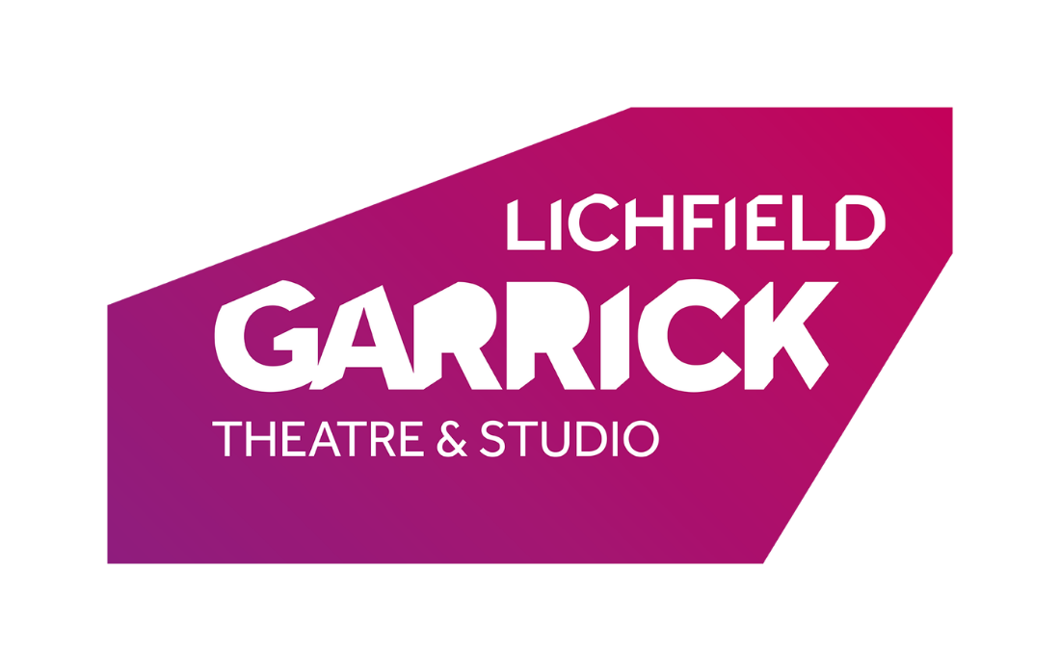
Escape Room Games Master

Thank you for your interest in the Escape Room Games Master post at the Lichfield Garrick.

Please find a job description and some background information enclosed.

How to Apply:
Please complete an application form and equal opportunities form (download from our website) and send it to:

Caitlin Evans
Lichfield Garrick
Castle Dyke,
Lichfield WS13 6HR

Or email: recruitment@lichfieldgarrick.com

Deadline for applications is midday on 28th February 2022 (however, early applicants will be reviewed and interviewed earlier. Should the right candidate be found, then the role will be taken down earlier.)

We look forward to receiving your application and thank you for your interest in Lichfield Garrick.
Background information

Lichfield Garrick produced a brand new Escape Room in August 2021 to bring an additional entertainment offering to its community. The Escape Room is a timed experience for up to six individuals to solve puzzles to unlock the room within the time given.

Additional Information on the Building:
Lichfield Garrick is a producing house, a receiving house, a cultural hub at the heart of the city and district of Lichfield and has a thriving community and outreach programme. As a modern, purpose-built theatre in Lichfield, the Garrick has an enviable programme of performances including drama, musicals, comedy, jazz, film and local theatre. This year we have an amazing production of Snow White, amongst other things planned for the pantomime season.

The main auditorium seats around 560 people, with no restricted viewing and allocated wheelchair spaces. The Studio is more flexible, offering an intimate space that can be arranged in a number of different layouts and seating up to 150 guests. It also houses Lichfield’s only cinema with full cinematic surround sound and full screen projection.

With a commitment to supporting the local community and the people within it, the Lichfield Garrick runs a number of programmes for young and old to take part in arts activities. Our programme is strong on traditional drama, but we are also building a new work strand and aim to support local and emerging artists. We are building our family audience and have a strong music following. The variety of other performances also offers opportunities for patrons with a wide range of tastes to enjoy a quality night out in the heart of the beautiful city of Lichfield. We are delighted that the theatre is now attracting help and advice from the Arts Council England as well as offering the escape room, a Santa’s Grotto and a cinema.

The pandemic has been a difficult time for theatres and the wider arts. We have been lucky enough to receive funding from DCMS/Arts Council England and from local sources such as Lichfield District Council, charitable trusts and many individual donations. We have endeavoured to open whenever we have been able to, in order to support the performers and technicians who work on touring shows. As a result of the period of closure, the Escape Room has been built and we are now looking for someone who can build on the achievements of the team, leading on customer experience as well as maintaining and running the room.

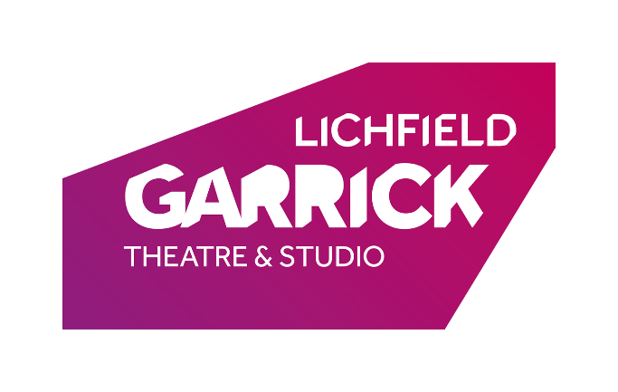

Post Title: Escape Room Games Master

Salary Grade: Minimum wage/living wage as age appropriate on a casual basis

Responsible to: Box Office Manager

Main Purpose of Post:

- To lead the effective day to day operation of the Escape Room and the running of the room.

- To ensure participants gain maximum enjoyment during their experience.

- To provide a lively, friendly, caring and efficient service to all customers and users of the Lichfield Garrick.

- Reset and sanitize the room, ensuring there are absolutely no mistakes

- Carry out repairs as required.

- Train staff in the running, repairs and maintenance of the Escape Room.

Main Duties

- To lead the day-to-day operation of the Escape Room including maintaining stocks of replacement parts/print outs.

- To provide excellent customer care to all Lichfield Garrick customers.

- To use the Box Office computer system to check Escape Room Reservations.

- To be trained and to implement health and safety, and fire evacuation procedures.

- To run and reset the escape room, answering any questions from participants and ensuring participants have a great time

- To ensure all Front of House areas are clean and tidy and carry out routine cleaning and maintenance of all Front of House areas immediately after Escape Room.

- Create a welcoming atmosphere for customers and support staff to maintain an award-winning welcoming experience.

- Take photos of participants and post to social media platforms in conjunction with marketing team.

- To keep up to date with all information relating to the Lichfield Garrick, its performances and other activities.

- To be willing to undergo relevant training as directed by the technical, Box Office and Front of House departments.

- To maintain a high standard of personal cleanliness and dress, this may include a corporate identity in the form of a staff uniform.

- To adhere to all Health & Safety and Lichfield Garrick procedures.

- Any other duties commensurate with the grade of post

The Lichfield Garrick reserves the right to vary the content of the job description, after consultation, to reflect the changes to the job without changing the general character of the post or level of responsibility.

Person Specification

Essential Criteria | Desirable Criteria | Means of Selection
Experience  Experience of working in a busy environment with members of the general public  Experience in customer care  Smart appearance and outgoing personality | Experience of the theatre environment  An active interest in theatre and the arts | Application Form / Interview
Qualifications  Basic computer skills  General education qualifications | Customer service | Application form /  Interview
Skills and Abilities  Excellent communication and people skills.  Ability to work well under pressure, and remain calm in a busy environment.  Ability to pay close attention to detail.  Ability to carry out repairs and have a practical mindset for problem solving  Ability to work as part of the Lichfield Garrick team |  | Application form/interview  Application Form / interview  Interview  Interview
Special Attributes  Intuition and adaptability  Able to work flexible hours to fit with the opening hours of the Escape Room, which will mainly include evenings, weekends and Bank Holidays  Willing to develop knowledge and experience. | Willing to learn and appreciate the running of a high quality escape experience. | Interview  Interview

This is a casual zero hours contract, however, as the Escape Room develops, this role may become a contracted hours contract.

