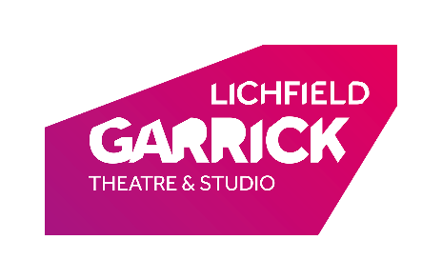
SPONSOR A COSTUME
Name:
Address:

Postcode
Phone Number
Email
This data is used for purposes of processing your donation and informing you of the benefits of donating to this project.
If we already hold your data, then we will continue to use it as we have done so in line with our privacy policy unless you ask us to do otherwise.

I enclose a cheque for £ _______
Please make cheques payable to Lichfield Garrick Theatre

PRINCIPAL COSTUME SPONSOR (from £200)
SUPPORTING COSTUME SPONSOR (from £75)
DONATION TO COSTUME FUND (any other amount)

GIFT AID DECLARATION – We can claim an additional 25p from HMRC per £1 donated if you are able to add Gift Aid to your donation.

Please tick here to confirm you are happy for Lichfield Garrick Theatre to treat all donations you have made for the four years prior to this year, and all donations you make from the date of this declaration until you notify us otherwise, as Gift Aid donations. To be eligible for Gift Aid, you need to be a UK tax payer. If you pay less income tax and/or capital gains tax than the amount of Gift Aid claimed on all your donations in that tax year it is your responsibility to pay any difference.
Thanks for your support!
Please return this form to Sponsor A Costume, Lichfield Garrick Theatre, Castle Dyke, Lichfield, WS13 6HR.
If you have any questions about your donation, this project, or any other fundraising activities, please get in touch with Matt Clay, Development Manager on 01543 412123 or matthew.clay@lichfieldgarrick.com.

